Static Code Analysis Using SonarQube

~By Krishan Rupani

SonarQube: SonarQube is an open-source platform developed by SonarSource for​ continuous inspection of code quality to perform automatic reviews with static analysis of code to detect bugs, code smells, and security vulnerabilities on 20+ programming languages.

In this experiment we will be using SonarQube for static code analysis.

We will use any of our maven project and then do it’s code analysis using SonarQube.

Move to your SonarQube folder and then open cmd there.

And run command StartSonar.bat

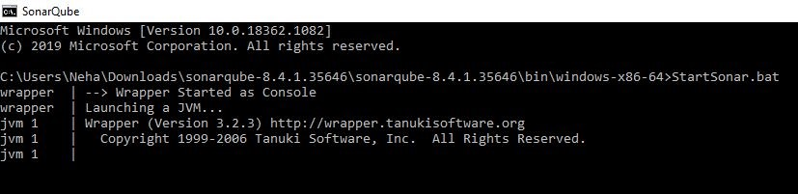

Go to localhost:9000

Default id & pass is admin



You can see a screen like without any project

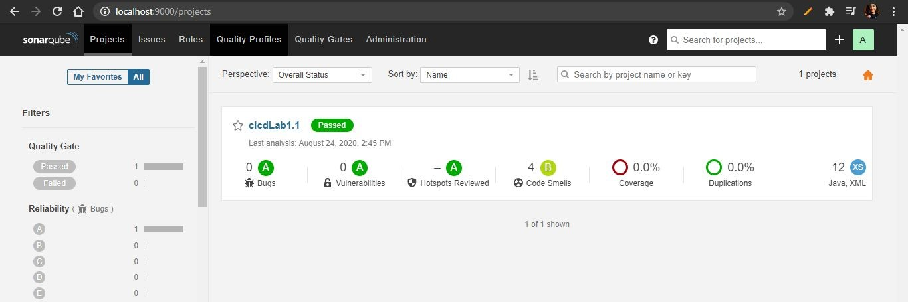

Move to your maven project folder

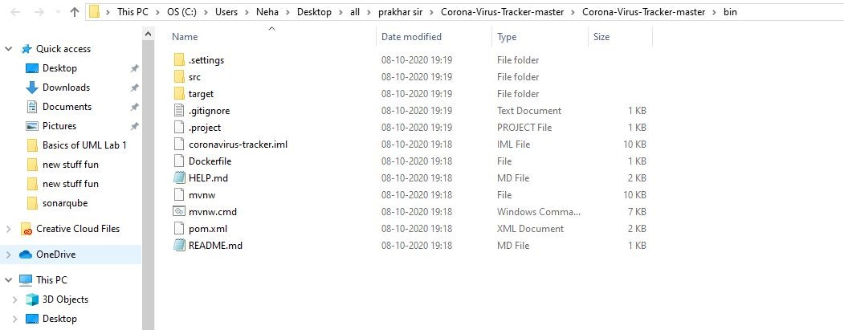

Run this command

mvn clean install sonar:sonar -Dsonar.host.url=http://localhost:9000

-Dsonar.analysis.mode=publish

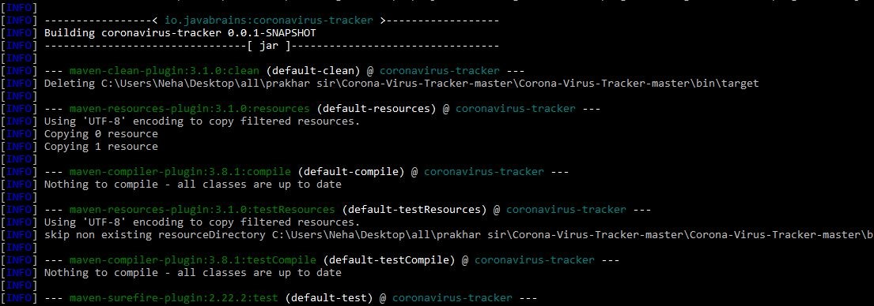

Build Success

